Weather Study Guide
- Draw pictures of the three states of water:
Liquid | Solid | Gas

- A pot of water sitting at room temperature would begin to turn to gas if you __________________________________________________________.
- Where could you put a bottle of water if you wanted to turn the liquid into a solid? Explain how that works. _______________________________________________________
_____________________________________________________________________
- Water freezes at ___________ degrees Fahrenheit and ___________ degrees Celsius.
- Water boils at ___________ degrees Fahrenheit and ___________ degrees Celsius.
- What are ground level clouds called? _________________
- Describe how clouds are formed. ____________________________________________ __________________________________________________________________________________________________________________________________________
- Draw a scene. Label the parts of the water cycle and explain each stage.
Use the following labels: sun, evaporation, condensation, precipitation, and collection of water.

- List 4 different types of precipitation.
  - ____________________ c. ____________________
  - ____________________ d. ____________________

- Explain how each weather instrument is used.
  - thermometer - ________________________________________________
  - rain gauge - __________________________________________________
  - barometer - __________________________________________________
  - wind vane - __________________________________________________
  - anemometer - ________________________________________________

- Write the letter of the weather instrument (above) that goes with each picture.
Weather Instrument | 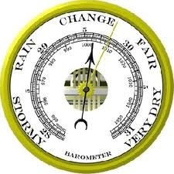 | 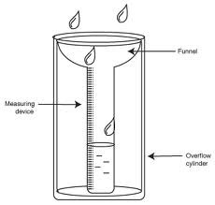 | 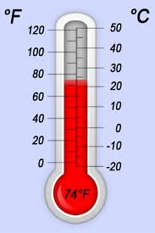 | 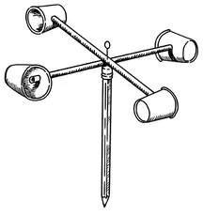 | 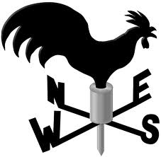
Letter

- Label the warm front and cold front. Draw an occluded front somewhere across the Northwest and a trough in between the cold and warm fronts. Also write the type of weather that can be expected with each front.
Warm front: _______________________

Cold front: _________________________

Occluded front: _____________________

Trough: ___________________________
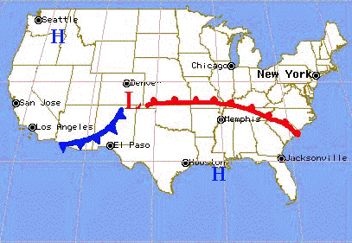

- According to the chart below, what was the record high (Rec High) temperature in July? ___________
- Based on the average rainfall (Avg Rain), would you expect the most precipitation in May or September and why? ______________________________________________________
_________________________________________________________________________
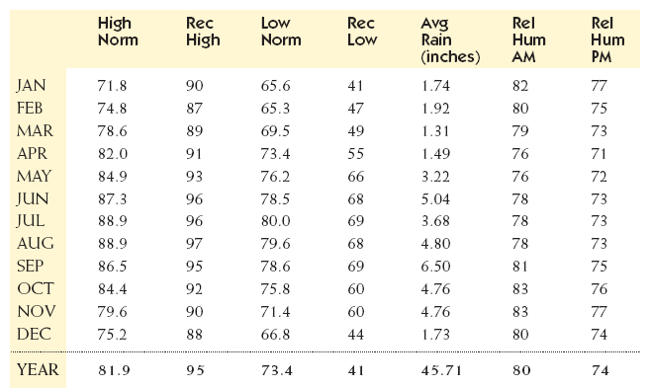

- What type of weather is occurring across northern Georgia? ___________________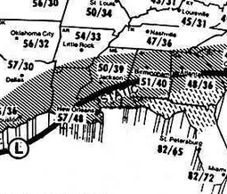
- Describe the differences between weather and climate. Make a t-chart or a Venn diagram (continue on the back if needed).

